University of Wah
Department of Computer Science



Submit to:

Ms. Muniba Khan

Submit by:

Muhammad Talha(101)
Muhammad Rafay Ali(063)

Course:

Data Structure and Algorithm_Lab

Reg No:

UW-24-CS-BS-101
UW-24-CS-BS-063
Section:

BS-CS-3rd-B

Open Ended Lab
Task A
1)How Priority Queues differ from normal queues.
Priority Queue is different from normal Queue because priority Queue execute based on the priority given to a Queue. On the other hand normal Queue just execute in normal way Like (FIFO) concept.
This makes both Queue different from each other.
Reference: Greek For Greek website

2) Why tree-based implementations (heaps, BSTs) are preferred over arrays in large-scale systems.
Tree based implementation is preferred over array because Array is in fixed size, Insertion or Deletion have time complexity O(n), Searching and reordering is difficult and poor scalability.
On the other hand tree didn’t have these problems. (heap)They have priority order, time complexity is O(log n).
(BST) They have sorted system, time complexity is O(log n), and have efficient searching.
Preferred: Tree because they have dynamic data handling, faster searching.
Reference: Greek For Greek website

Task B
Priority Queue

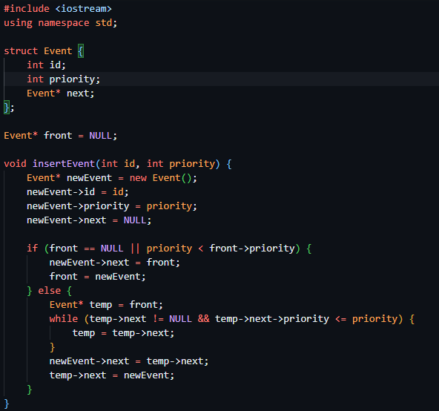
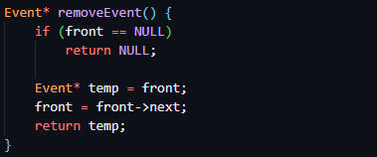
Tree
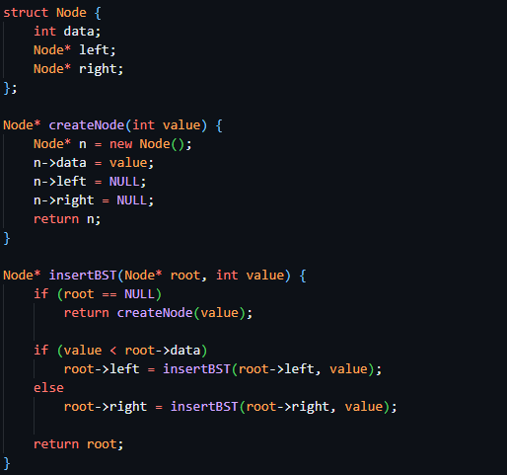
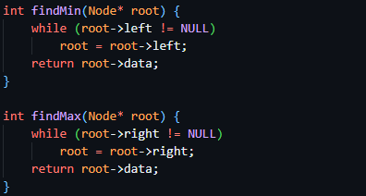

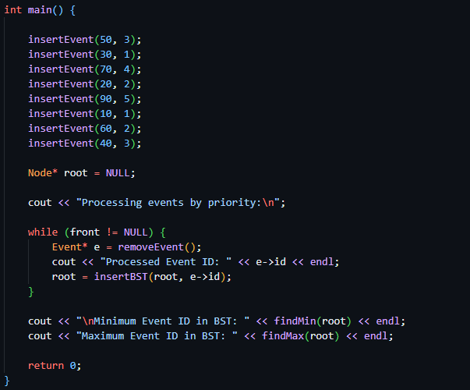

Output

Linked List

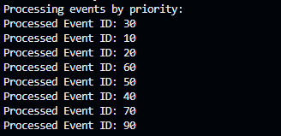

Tree



Task C
- Implementation
This Priority Queue and Tree are implemented above both contain
- Test
- Random Value
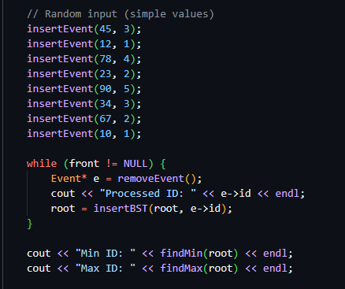
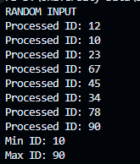
- Sorted Value
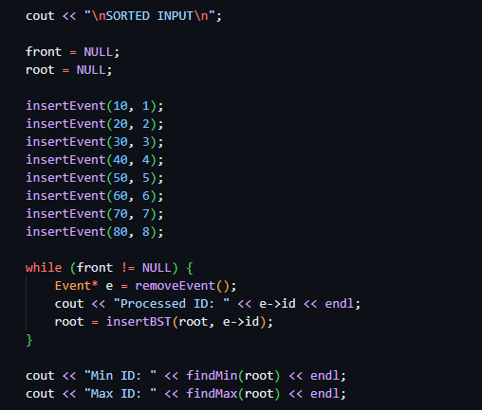
Output
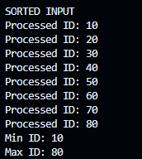

- Analyze
a)

Array : O(n)
Linked List : O(log n)

b)

In tree:
Slow Searching, High CPU usage, Unsafe for real-time systems.
Array-Based Priority Queue
Deletion is slow, Not suitable for large systems, Can delay critical events
No Error Handling
Overflow, System instability, Safety risks in real-time applications

Reference

Greek For Greek Web Site
W3 School Web Site
Google (main Source)

